Team Members: D. Butcher, T. Kambal, R. Nelson, A. Vaccaro

02/19/2023

Milestone# 2

Group Name: Bravo

Case Study: Outland Adventures

Revised ERD:

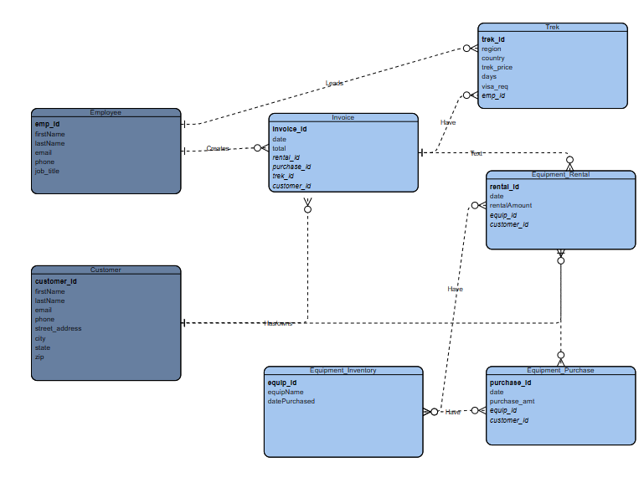

Screenshot of tables:

